Activities data EDA and Summary

The google colab notebook for the same is available [HERE](https://colab.research.google.com/drive/1gpY6Q5beSo8TND-Pmld_thGQYjXDGsxR#scrollTo=PlAShnCRICpv)

* The data available is in a CSV format, we have 7 columns
  + 'age',
  + 'Id',
  + 'Name',
  + 'activity_type',
  + 'content',
  + 'game_type',
  + 'cultures',
  + 'learning_level',

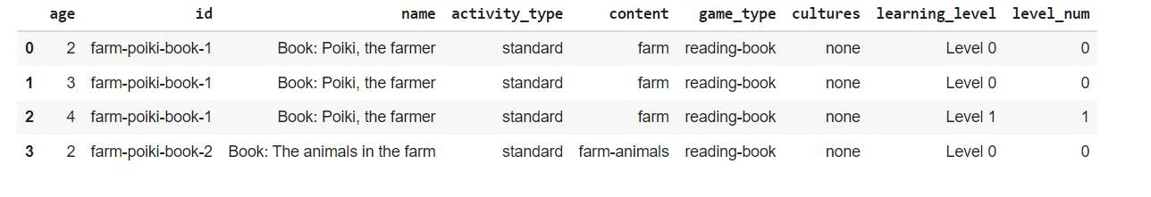

* The column types are

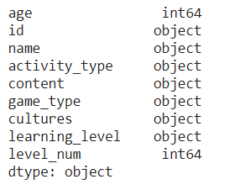

There are a total of 403 different activities for all age groups. [2yr - 6 yr ]

Further description

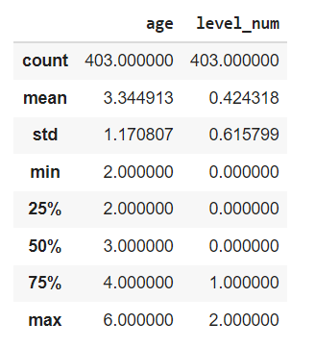

**Column-Game_type**

This column describes the game genre

* We have 19 unique game_types in our dataset [with their frequencies]

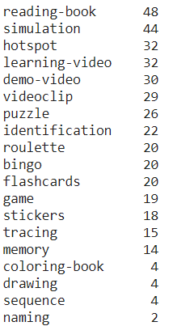

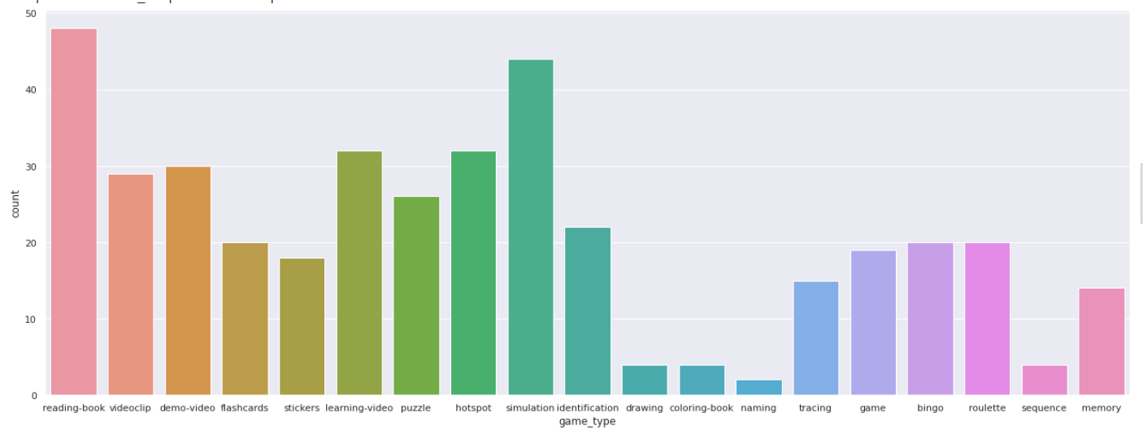

The most common activity is the *‘reading book’* with *‘naming’* being the least popular

**Column-Content_type**

This column describes the category the game is related to

* We have 47 different content items in our dataset [ with their frequencies]

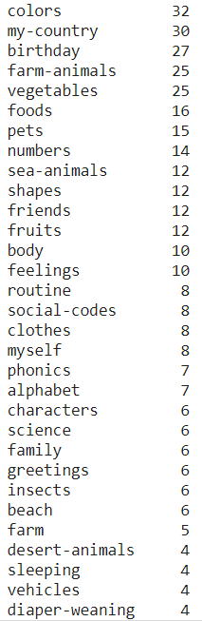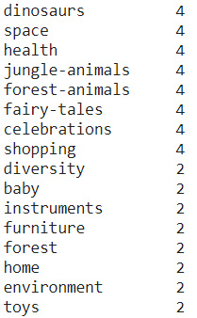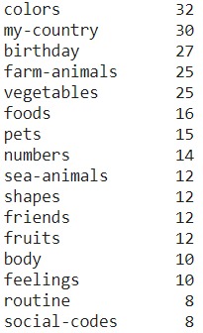

‘Colors’ is the most appearing category, ‘toys’ is the least

**Column-Activity_type**

This column describes the activity type the game is related to

* We have 3 different categories in this column [ with their frequencies]

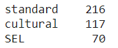

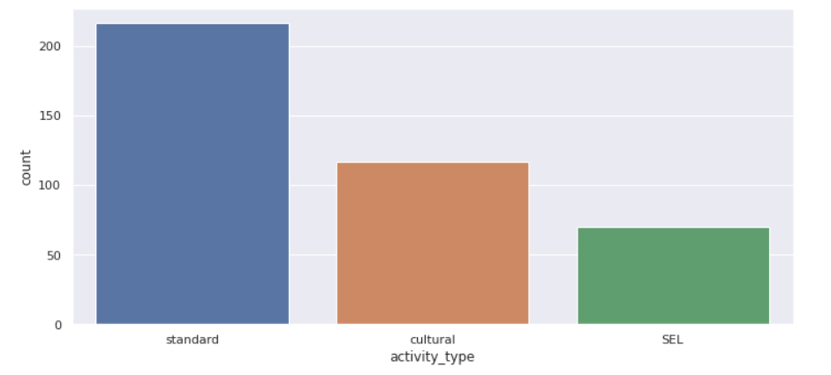

**Games for 2 year olds**

We have 104 games for 2 year olds.

Game types

* There are 15 (out of 19) game types available.
* The missing game types are
  + bingo
  + roulette
  + sequence
  + Memory

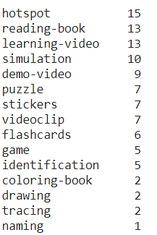

Game types for 2 yr olds with their frequencies

* We can observe *hotspot* is the most popular game type

Content types

* There are 37 (out of 47) content categories types.
* The missing content types are
  + Myself
  + Shopping
  + Instruments
  + Health
  + Forest
  + Space
  + Home
  + Characters
  + Science
  + Alphabet

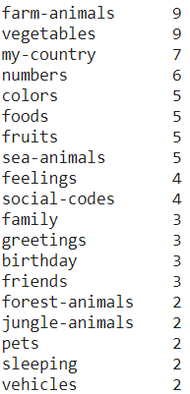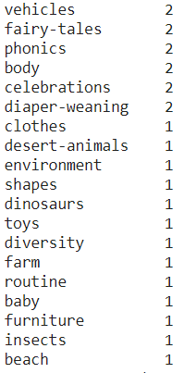

Content type with their frequencies for 2 yr olds

* *Farm animals* is the content category most games belong to

Activity type

* All three activity types are present for 2 year olds

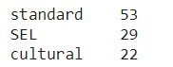

* We can observe that standard activities are almost double of SEL and cultural activities.

**Games for 3 year olds**

We have 155 games for 3 year olds.

Game types

* We have all the game types available for 3 year olds

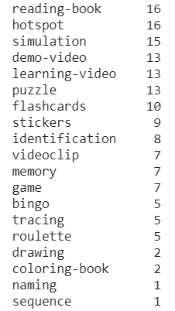

Game type[yr-3] with freq.

* *‘Reading-book’* is the game type with the highest frequency.

Content type

* Games with all content types are available for 3 yr olds.

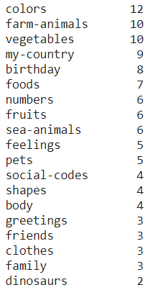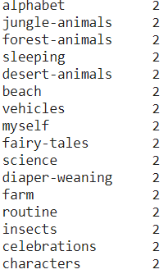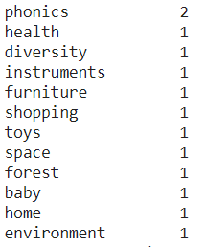

Activity type

* All activity types are available for games for 3 year olds

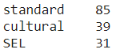

**Games for 4 year olds**

We have 72 different games for 4 year olds.

Game types

* There are 16 (out of 19) game types available.
* The missing game types are
  + 'drawing',
  + 'coloring-book',
  + 'naming'

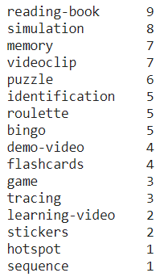

Game types for 4 yr olds with their frequencies

* We can observe *reading-book* is the most popular game type

Content types

* There are 32 (out of 47) content categories types.
* The missing content types are
  + 'Environment',
  + 'Diversity',
  + 'Toys',
  + 'furniture',
  + 'vehicles',
  + 'family',
  + 'jungle-animals',
  + 'diaper-weaning',
  + 'forest-animals',
  + 'fairy-tales',
  + 'baby',
  + 'Social-codes',
  + 'celebrations',
  + 'sleeping',
  + 'greetings'

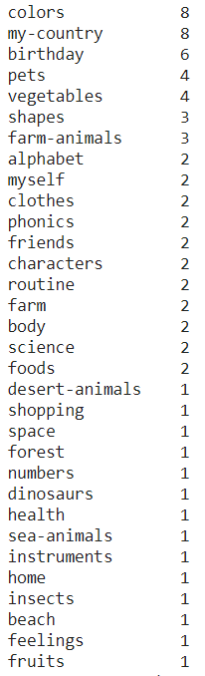

Content type with their frequencies for 4 yr olds

* *Colors* is the content category most games belong to

Activity type

* All three activity types are present for 4 year olds

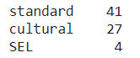

* We can observe that standard activities are almost 1.5x of cultural activities and very few SEL activities are available.

**Games for 5 year olds**

We have 45 games for 5 year olds.

Game types

* There are 11 (out of 19) game types available.
* The missing game types are
  + 'drawing',
  + 'memory',
  + 'Hotspot',
  + 'puzzle',
  + 'stickers',
  + 'flashcards',
  + 'coloring-book',
  + 'naming'

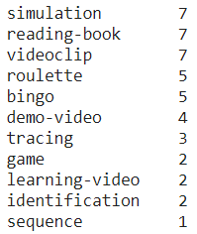

Game types for 2 yr olds with their frequencies

* We can observe *simulation* is the most popular game type

Content types

* There are 23 (out of 47) content categories types.
* The missing content types are
  + 'environment',
  + 'forest-animals',
  + 'baby',
  + 'diversity',
  + 'furniture',
  + 'instruments',
  + 'Fairy-tales',
  + 'Social-codes',
  + 'sleeping',
  + 'Feelings',
  + 'toys',
  + 'jungle-animals',
  + 'Dinosaurs',
  + 'Farm',
  + 'celebrations',
  + 'Desert-animals',
  + 'family',
  + 'sea-animals',
  + 'vehicles',
  + 'fruits',
  + 'diaper-weaning',
  + 'Forest',
  + 'home',
  + 'greetings'

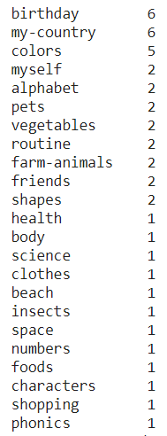

Content type with their frequencies for 5 yr olds

* *Birthday* is the content category most games belong to

Activity type

* All three activity types are present for 5 year olds

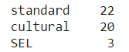

* We can observe that standard activities are almost the same as cultural activities while SEL activities are very few in number.

**Games for 6 year olds**

We have 27 games for 6 year olds.

Game types

* There are 10 (out of 19) game types available.
* The missing game types are
  + 'drawing',
  + 'Memory',
  + 'hotspot',
  + 'puzzle',
  + 'demo-video',
  + 'stickers',
  + 'flashcards',
  + 'coloring-book',
  + 'naming'

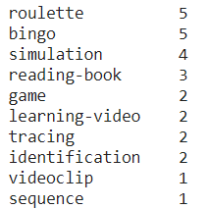

Game types for 6 yr olds with their frequencies

* We can observe *roulette* is the most popular game type

Content types

* There are 19 (out of 47) content categories types.
* The missing content types are
  + 'environment',
  + 'forest-animals',
  + 'numbers',
  + 'baby',
  + 'vegetables',
  + 'diversity',
  + 'furniture',
  + 'instruments',
  + 'fairy-tales',
  + 'social-codes',
  + 'Sleeping',
  + 'feelings',
  + 'toys',
  + 'my-country',
  + 'jungle-animals',
  + 'phonics',
  + 'dinosaurs',
  + 'Farm',
  + 'celebrations',
  + 'Desert-animals',
  + 'family',
  + 'sea-animals',
  + 'vehicles',
  + 'fruits',
  + 'diaper-weaning',
  + 'forest',
  + 'home',
  + 'greetings'

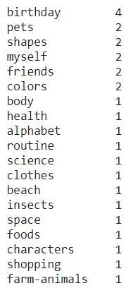

Content type with their frequencies for 6 yr olds

* *Birthday* is the content category most games belong to

Activity type

* All three activity types are present for 6 year olds

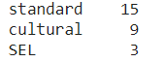

* We can observe that standard activities are almost double of cultural activities and SEL activities are very few in numbers .

**Countries for cultural activities**

* Brazil,
* US,
* UK,
* Denmark,
* Spain,
* Mexico,
* Canada,
* Portugal,
* Australia,
* France, [Available for 8 activities]
* Italy, [Available for 8 activities]
* Germany [Available for 8 activities]

**Final Thoughts**

* The data has 403 activities across all age groups.
* Activities are less than 30 (27) for year 6 age group.
* 28 content type activities are missing for the year 6 age group.
* SEL activities are quite less compared to cultural and standard activities.
* ‘Reading book’ game type is the game that tops in frequency across all age groups.